|  |
| --- |
| Table of contents |

General information 3

Broad areas of learning 3

Cross-curricular competencies 3

ESL competencies 3

Material needed 4

Evaluation criteria 4

Essential knowledge 5

Summary chart 6

Task #1 – Big Book 7

Task #2 – Song 9

Task #3 – Mask of Ironman 10

Task #4 – Mini Book 11

Bibliography 12

Appendixes

#1 : Body parts of Ironman flashcards 13

#2 : Other body parts flashcards 14

#3 : Lyrics – “Head and shoulders remix” 15

#4 : Memory game of Ironman 16

#5 : Mask of Ironman template 22

#6 : Model of Ironman mask 22

#7 : Vocabulary sheet for the Mini Book 23

#8 : Model of a Mini Book 26

#9 : Mini Book template 27

|  |
| --- |
| General information |
| Title of the lesson   * Let’s rebuild Iron Man!   \*\* Inspired by the book: “The New Clues to English – English as a Second Language (Second Cycle Elementary)” |
| Target learners/Grade   * Elementary, Cycle 2, Grade 3 |
| Duration   * 4 periods of approximately 45 minutes each |
| Purpose   * The purpose is to teach children to identify body parts in English. |

|  |
| --- |
| Broad areas of learning |
| * Health and well-being |

|  |  |  |  |
| --- | --- | --- | --- |
| Cross-curricular competencies | | | |
| Intellectual | Methodological | Personal and social | Communication related |
| * To use information * To use creativity | 🗴 | * To cooperate with others | * To communicate appropriately |

|  |  |  |
| --- | --- | --- |
| ESL Competencies | | |
| To interact orally in English | To reinvest understanding of oral and written texts | To write texts |
| * The student reacts to message using strategies * The student takes the initiative to transmit oral messages using strategies * The student maintains oral interaction using strategies | * The student prepares to listen to and read texts using strategies * The student demonstrates understanding or oral and written texts using strategies * The student carries out meaningful tasks using strategies | * The student prepares to write texts using strategies * The student compose texts using strategies |

|  |
| --- |
| Materials needed |
| * Materials needed will be presented in the description of every task. |

|  |  |
| --- | --- |
| Evaluation criterias | |
| Cross-curricular competencies | ESL Competencies |
| * **Competency 1: To use information** * Consultation of various sources * Appropriate selection of information * Logical organization of information * Effective use of information * **Competency 4 :To use creativity** * Diversity of suggested ways of proceeding * Originality of connections among the elements * Dynamism of the process * Identification of possible improvement in the innovation process * **Competency 8:To cooperate with others** * Recognition of the needs of others * Appropriate attitudes and behaviors * Commitment to the work of the team * **Competency 9: To communicate appropriately** * Clarity, appropriateness and precision of the purpose of the communication * Coherence of the message * Use of appropriate symbols or vocabulary * Observance of codes and conventions * Self-analysis and evaluation | * **Competency 1: To interact orally in English** * Use functional language * Use of strategies * Participation in exchange * Pronunciation * **Competency 2: To reinvest understanding of oral and written texts** * Use of strategies * Demonstration of understanding of key elements and overall meaning * Carrying out tasks * **Competency 3: To write texts** * Use of strategies * Compliance with instructions * Language conventions targeted for tasks * Characteristics of final product |
| Evaluation means   * The cross-curricular competencies are taken into account but are no more evaluated for the report card. * Traces of strategy use for the mini-book * Mini-book evaluation according to the keywords * Observation grids * Self-evaluation and peer evaluation | |

|  |  |  |
| --- | --- | --- |
| Essential knowledge | | |
| Functional language | | Strategies |
| **Useful expressions** | **Vocabulary** |
| * Instructions * Delay speaking * Asking for help and clarification * Identification * Requests information * Agreement, disagreement, opinions * Expressions to make rejoinders | * Theme-related vocabulary * Vocabulary related to immediate environment * Questions words * Yes/no questions | * Asking for help or clarification * Planning * Attention * Use of prior knowledge * Inferring * Practice * Resourcing * Scanning * Cooperation * Risk-taking * Accepting not being able to understand everything listened to or read |
| Language convention | Text components | Cultural product |
| * Word order (simple sentence) * Articles * Regular plurals * Spellings (found in explicit models and resources targeted for carrying out tasks) | * Key element * Overall meaning | * Texts (story) * Media (song) * Game (memory game) * Famous people * Landmarks |

|  |  |  |
| --- | --- | --- |
| Summary chart | | |
| * **The Summary Chart is to show the links between the competencies, tasks and evaluation tools.** | | |
| Task duration | Competency | Evaluation tool |
| **Trigger activity** | 🗴 | 🗴 |
| **Task 1**  Big Book | * **C1:** To reinvest understanding of oral and written texts * **CCC9:** To communicate appropriately |  |
| **Task 2**  Song | * **C2:** To interact orally in English * **CCC8:** To cooperate with others |  |
| **Task 3**  Ironman mask | * **CCC4:** To use creativity | 🗴 |
| **Task 4**  Mini Book | * **C1 :** To reinvest understanding of oral and written texts * **C3:** To write texts * **CCC1:** To use information * **CCC4:** To use creativity |  |
| **Integration** | * **C2:** To interact orally in English * **CCC9:** To communicate appropriately |  |

|  |  |  |  |  |
| --- | --- | --- | --- | --- |
| TASK #1 – PROCEDURES | | | | |
|  | The teacher | The students | Grouping | Time |
| Trigger activity | * Asks students about their favorite super heroes. | * Listen to the questions and answer. |  | 5 minutes |
| Pre-activity | * Asks questions on what they know about body parts. * What body parts can you name in English? * Presents flashcards (Appendix 1). * Explains words of the flashcards (new vocabulary). * Continues showing flashcards and ask students to name the body part featured on each card. * Uses corrective feedback and positive reinforcement. | * Listen to the teacher. * Answer questions. * Observe flashcards. * Learn new vocabulary. |  | 10 minutes |
| Main Activity  **Big Book** | * Presents the book (ask students to predict the story) * “What do you think this story is about?” * 1st reading: no questions * 2nd reading: ask questions while reading (here is some examples): * What is this story about? * What is happening to Iron Man? * Do you think the little boy can help Iron Man? * Do you think the little boy can find all of Iron Man’s body parts? * Do you see any body parts in this picture? * Which ones? * Throughout the second reading, the teacher uses corrective feedback and encourages learners with positive reinforcement. | * Predict the story. * Listen to the 1st reading. * Answer teacher’s question during the 2nd reading. * Participate by answering questions during the second reading. |  | 20 minutes |
| Post-activity  **Simon Says** | * The teacher presents and explains the game clearly. * The teacher has students stand up to play the game. * The teacher will instruct students while using flashcards showing the body part. * This game has two objectives. The first one is for students to associate the English words used to describe body parts with their own body parts. The second objective is to develop students understanding of instructions. Therefore, when the teacher says “Simon says”, the students will respond by following the instruction given (e.g. Simon says: touch your arm). But when the teacher simply says “Touch your arm”, students will respond appropriately, according to the rules which, in this case, mean that they will not touch their arm.   ***Examples:***   * Simon says: touch your head. * Simon says: touch your arm. * Touch your foot. * Touch your leg. * Simon says: touch your nose. * And so on... * Throughout the activity, the teacher will use corrective feedback and encourage student participation by giving positive reinforcement. | * Students listen to the teacher’s instructions before and during the game. * Students participate using total physical response (e.g.: touching their head when the teacher says: “Simon says: touch your head”). * Students pay attention to the flashcard being shown. * Students respond to corrective feedback. * Students demonstrate a clear understanding of the instructions given. |  | 10 minutes |

|  |  |  |  |  |
| --- | --- | --- | --- | --- |
| TASK #2 – PROCEDURES | | | | |
|  | The teacher | The students | Grouping | Time |
| Pre-activity | * Reviews the flashcards of Ironman’s body parts (Appendix 1). * Do you remember how we call this…? * Introduces new body parts with flashcards (Appendix 2). The new ones are related to the song. | * The students answer the questions and interact orally in English with the teacher. * They listen and repeat the new vocabulary. |  | 10 minutes |
| Main Activity  **Song** | * Tells the students the title of the song: “Head and Shoulders”. She tells them that they already know this song (acquired knowledge) or if they know it in French. They will learn a part with the new body parts. * Distributes the lyrics to the students. (Appendix 3) * Plays the recording one time. * Goes over the song line by line explaining the new vocabulary showing the flashcards. * Sings the song one line at a time with the gestures. * Focuses on the second part of the song which is new for the students. * Plays the recording a second time | * Students listen carefully to the song. * They repeat the lines with the teacher. * Students stand up and sing along and/or do the gestures. |  | 20 minutes |
| Post-activity  **Memory game** | * Tells the kids they will play a game with Ironman. She explains the memory game. (Appendix 4) * Explains the rules and models it on the board with one of the students. * Writes sentences for interactions between the students and explain them: * It’s your turn. * It’s my turn. * You are next. * Who is next? * I found it! * Groups the students randomly 4 by 4. | * Students listen carefully to the teacher. * They repeat the sentences with the teacher and ask questions if they do not understand. * Students get in groups. * They start playing the games using the interaction sentences. | Groups of 4 | 15 minutes |

|  |  |  |  |  |
| --- | --- | --- | --- | --- |
| TASK #3 – PROCEDURES | | | | |
|  | The teacher | The students | Grouping | Time |
| Pre-activity | * Shows template of the mask * White one (Appendix 5) * Model already done (Appendix 6) * Shows materials needed for the activity * “Take your scissors, coloring pen and I have string that I will give you to attach your mask” (when saying the sentence, the teacher shows all the objects and wrote on the board instead of using flashcards). * Explains how to create the mask : * Do coloring * Take the string and attach it to the mask. | * Listen to the teacher’s instructions * Take out the material needed |  | 5 minutes |
| Main Activity  **Mask of**  **Ironman** | * Distributes the template (\*note that eyes and mouth of the mask must be removed before passing the template as it is too difficult, for the students, to cut them) * Helps students to attach their masks if necessary * Throughout the activity, the teacher encourages learners with positive reinforcement. | * Create their masks * Ask for help if necessary |  | 30 minutes |
| Post-activity  **Song** | * When masks are finished, the teacher can encourage students to wear their new Ironman mask to sing the song. * Play the song one or two times. | * Are wearing their new masks and sing the song “Head and shoulders Remix” |  | 10 minutes |

|  |  |  |  |  |
| --- | --- | --- | --- | --- |
| TASK #4 – PROCEDURES | | | | |
|  | The teacher | The students | Grouping | Time |
| Pre-activity | * The teacher reviews the flashcards used when he read the Big Book * Asks students if they remember what is it (showing flashcard of Appendix 2 and hiding the word on it) * Introduces the vocabulary words sheet (Appendix 7). * Presents a model of Mini Book (Appendix 8). * Gives instructions explaining the concept of the Mini Book: * To choose in the vocabulary words sheet the heroes/ place/ obstacle/ etc. they want in their stories. | * Review the vocabulary words with the teacher. |  | 5 minutes |
| Main Activity  **Mini Book** | * The teacher distributes the Mini Books template to the students. (Appendix 9). | * Listen to instructions. * Ask questions if necessary. * Must write their own version of the story using the vocabulary words on list. * Draw pictures explaining what is happening in their story. |  | 30 minutes |
| Integration  **Story sharing** | * The teacher encourages students to share their story they have created with the class. | * Students share their story with the class. |  | 10 minutes |

|  |
| --- |
| Bibliography |
| BOLDUC Ioland, SASSO Jean. *The New Clues to Englsih: English as a Second Language*. Second Cycle Elementary, Les Éditions CEC, Anjou, (Québec) Canada, 130 p. |

Appendix #1

Appendix #2

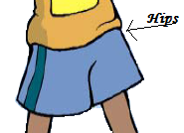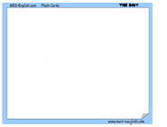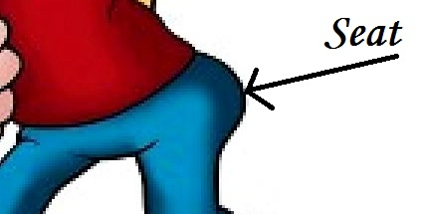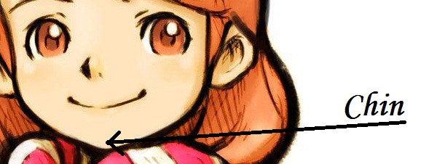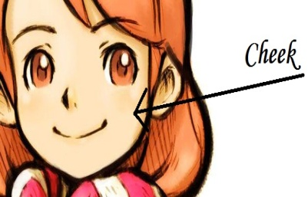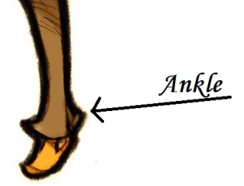

Appendix #3

**Head and shoulders remix**

Head, shoulders, knees and toes, knees and toes

Head, shoulders, knees and toes, knees and toes

And eyes and ears and mouth and nose

Head, shoulders, knees and toes, knees and toes

Ankle, elbow, feet and seat, feet and seat

Ankle, elbow, feet and seat, feet and seat

And hair and hips and cheek and chin

Ankle, elbow, feet and seat, feet and seat

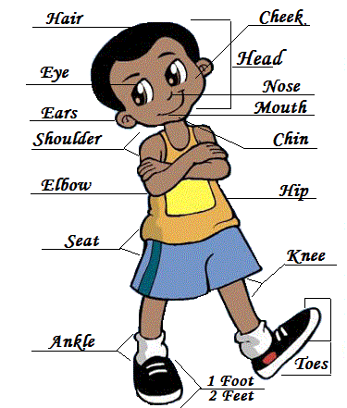

Appendix #4

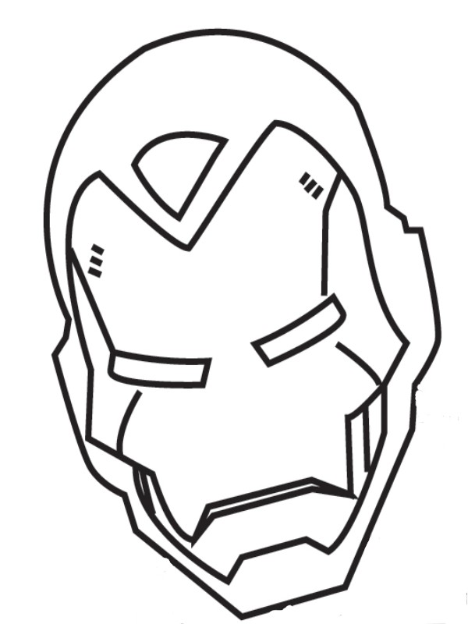

Appendix #5

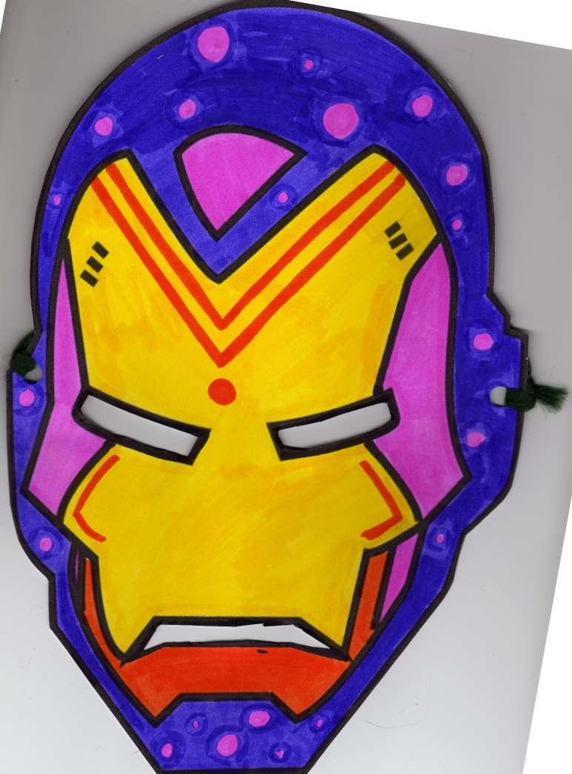

Appendix #6

Vocabulary

Appendix #7

Heroes

|  |  |  |  |  |  |
| --- | --- | --- | --- | --- | --- |
| C:\temp\Fichiers Internet temporaires\Content.Word\coloring_book_page_jpg_468x609_q85[1].jpg | C:\temp\Fichiers Internet temporaires\Content.Word\7405_soldier[1].gif |  | http://coloringpagesplus.com/people/people-teacher1.gif | [http://www.pdoodle.com/thumbnails/ballerina3_tn.jpg](http://www.pdoodle.com/pdfs/ballerina3.pdf) | C:\temp\Fichiers Internet temporaires\Content.Word\195x232_princess01[1].gif |
| **Prince Charming** | **John the**  **soldier** | **Matt the**  **policeman** | **Jo the**  **teacher** | **Scarlett the**  **ballerina** | **Elizabeth the**  **princess** |
| http://www.coloring-pictures.net/drawings/hockey/ice-hockey.gif | http://t1.gstatic.com/images?q=tbn:UTPl0PTDpfbk1M:http://thecoloringspot.com/images/sports/soccer-player.jpg&t=1 | http://www.abcteach.com/Activities/firefi3.gif | http://coloring.thecolor.com/color/images/Veterinarian.gif | http://www.mountnittany.org/assets/images/krames/2827.jpg | http://1.bp.blogspot.com/_Kh0CZuWd0T8/SlCOisDgmtI/AAAAAAAAD_E/NbWOCS9ORps/s400/fairy+coloring+page+(10).gif |
| **Patrick the**  **hockey player** | **David the**  **soccer player** | **Eric the**  **fireman** | **Isabella the**  **veterinarian** | **Amy the**  **doctor** | **Tootsy the**  **fairy** |

Obstacles

|  |  |  |  |  |  |
| --- | --- | --- | --- | --- | --- |
| C:\temp\Fichiers Internet temporaires\Content.Word\Mountain_Behind_House[1].png | <http://freekidscoloringpages.net/wp-content/uploads/2009/04/dragon%20coloring%20pages%206.gif> | http://www.freeprintablecoloringpages.net/samples/Gardening/Fence_And_Butterflies.png | C:\temp\Fichiers Internet temporaires\Content.Word\door[1].gif | http://www.freshcoloring.com/wp-content/uploads/yapb_cache/house.10vo7o362x008g0oos0g8g4cc.91yyvwac750kkk8wk8gg8csco.th.jpeg | http://www.supercoloring.com/wp-content/main/2009_06/skyscraper-in-big-city-coloring-page.jpg |
| **Mountain** | **Dragon** | **Fence** | **Door** | **House** | **Building** |
| http://a62.g.akamai.net/7/62/10424/8c4858a3babbf2/www.crayola.com/coloring-pages/media/print/632.gif | http://worksheetsforkids.net/wp-content/uploads/2010/04/bus-sekolah.jpg | http://www.dragoart.com/tuts/pics/9/2115/9187/how-to-draw-a-tornado-step-4.jpg | C:\temp\Fichiers Internet temporaires\Content.Word\coloring_book_page_jpg_468x609_q85[1].jpg | http://www.tsl.state.tx.us/ld/projects/trc/2005/manual/craftillos/tree.jpg | C:\temp\Fichiers Internet temporaires\Content.Word\spaceship[1].gif |
| **Fountain** | **Bus** | **Tornado** | **Plane** | **Tree** | **Spaceship** |

Actions

|  |  |  |  |  |
| --- | --- | --- | --- | --- |
| http://www.printactivities.com/ColoringPages/Horse_Coloring_Pages/Kids_with_Horses/Girl_brushing_horse.gif | http://cdn.freecoloringsheets.net/samples/Sports/Ice_Skating.png | http://www.printactivities.com/ColoringPages/Soccer/Coach-KickingBall.gif | http://coloringpages101.com/coloring_pages/Maya_the_Bee/FlyingWillythebeecoloringpage_bxdlz.jpg | Ballet Elephant color page Ballet, Ballerina and Dancing color page, sports coloring pages, color plate, coloring sheet,printable coloring picture |
| **Pets** | **Ice-skates** | **Kicks** | **Flies** | **Dances** |
| http://www.christysclipart.com/wwwroot/kid_walk.gif | http://www.colormegood.com/colormegoodPDFthumbnails/sports/athleticstrackandfield/trackandfield06.jpg | http://www.familyshoppingbag.com/images/full/Girl_Jumping_Rope_317603.gif | http://printables.kaboose.com/img/camp_climb_rdax_65.jpg | http://www.kookerkids.com/Coloring/st_patricks_day/images/St-Patrick%27s-Day-0096.gif |
| **Walks** | **Runs** | **Jumps** | **Climbs** | **Drives** |
|  | | | | |

Body parts

|  |  |  |  |  |  |
| --- | --- | --- | --- | --- | --- |
|  |  |  | http://0.tqn.com/d/homeschooling/1/0/j/c/colorn9.png |  |  |
| **Head** | **Hair** | **Mouth** | **Nose** | **1 eye**  **2 eyes** | **1 ear**  **2 ears** |
|  |  |  |  |  |  |
| **1 toe**  **2 toes** | **1 hand**  **2 hands** | **1 finger**  **2 fingers** | **1 foot**  **2 feet** | **1 arm**  **2 arms** | **1 leg**  **2 legs** |

Places

|  |  |  |  |  |
| --- | --- | --- | --- | --- |
| C:\temp\Fichiers Internet temporaires\Content.Word\theatercoloringsheetthumb[1].jpg | http://www.doodle-art-alley.com/images/foresttrees.jpg | http://www.edupics.com/coloring-page-visiting-the-zoo-dl6481.jpg | <http://coloringpagesforkids.info/wp-content/uploads/2009/04/castle%20coloring%20pages%206.jpg> | http://assets.handipoints.com/stamps/happy/my_neighborhood/dads_office_ink.jpg |
| **Theatre** | **Forest** | **Zoo** | **Castle** | **Office** |
| C:\temp\Fichiers Internet temporaires\Content.Word\beach-coloring-page-source_wfy[1].jpg | http://www.freeprintablecoloringpages.net/samples/People_And_Places/School.png | C:\temp\Fichiers Internet temporaires\Content.Word\2fe6e716-6c87-4f8d-9cd2-9c2a00be087a[1].jpg | http://thekidsbookconnection.com/kidstuff/2coloring_city_450.gif | C:\temp\Fichiers Internet temporaires\Content.Word\footballstadium03[1].jpg |
| **Beach** | **School** | **Park** | **City** | **Stadium** |

|  |  |
| --- | --- |
| http://www.supercoloring.com/wp-content/main/2008_11/cute-girl-coloring-page.jpg | [http://www.edupics.com/en-coloring-pictures-pages-photo-boy-dl10011.jpg](http://arcticboy.arcticboy.com/view2.php?q=Picture%20Of%20Boy%20Coloring%20Page&url=http://www.edupics.com/en-coloring-pictures-pages-photo-boy-dl10011.jpg) |
| **Girl**  **Pronoun : she** | **Boy**  **Pronoun : he** |

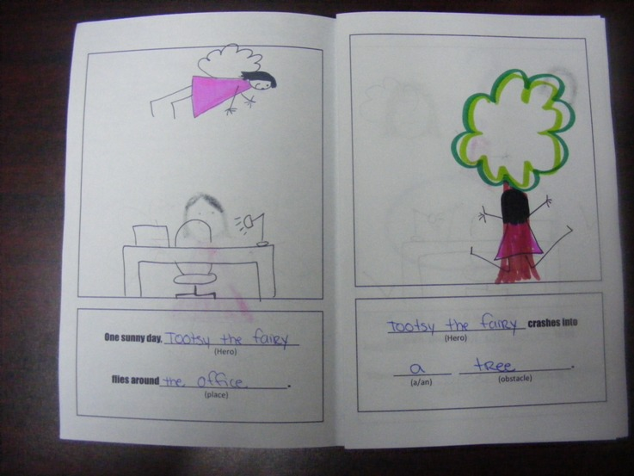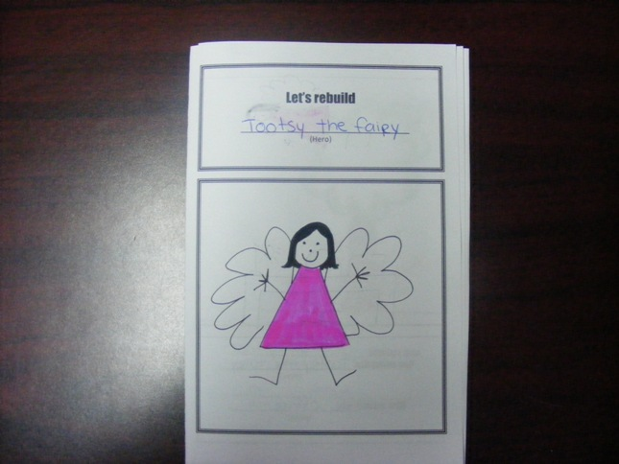

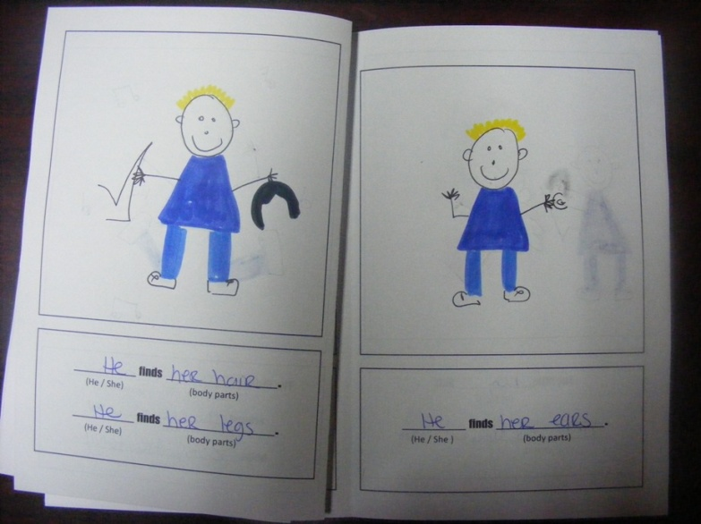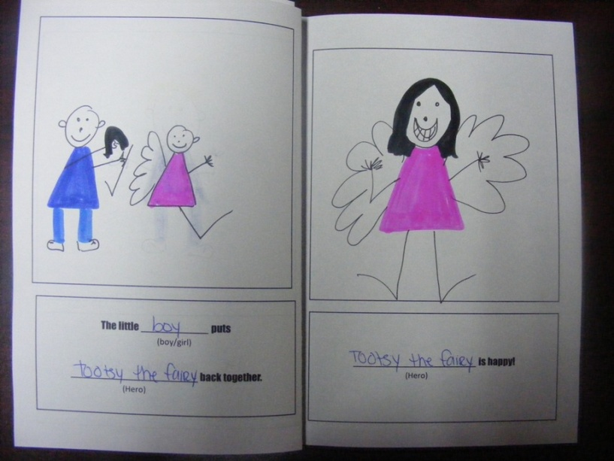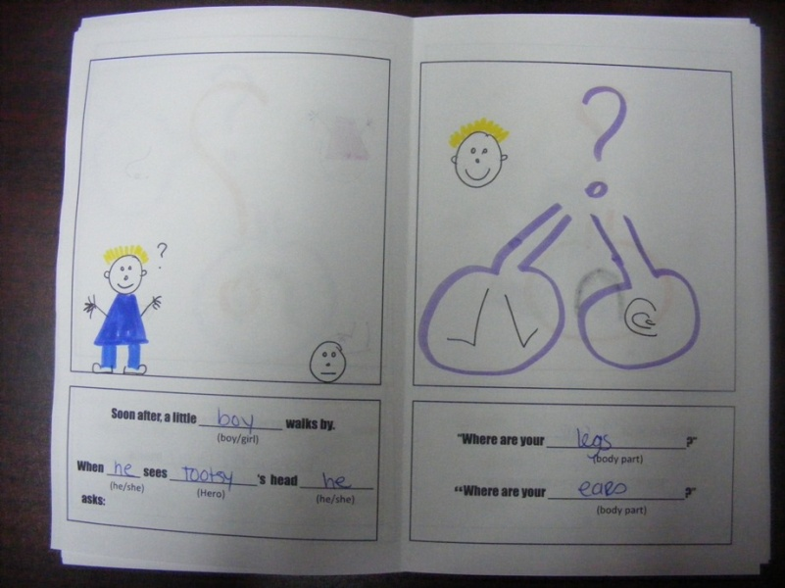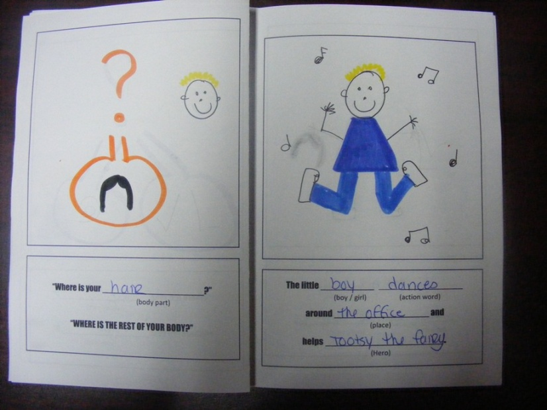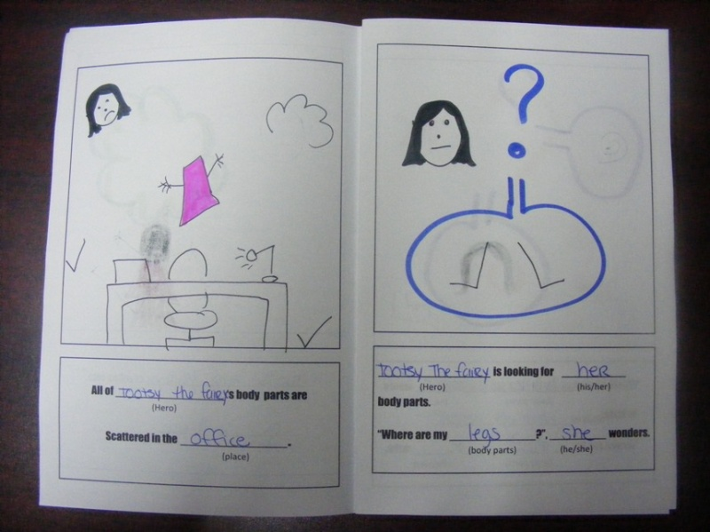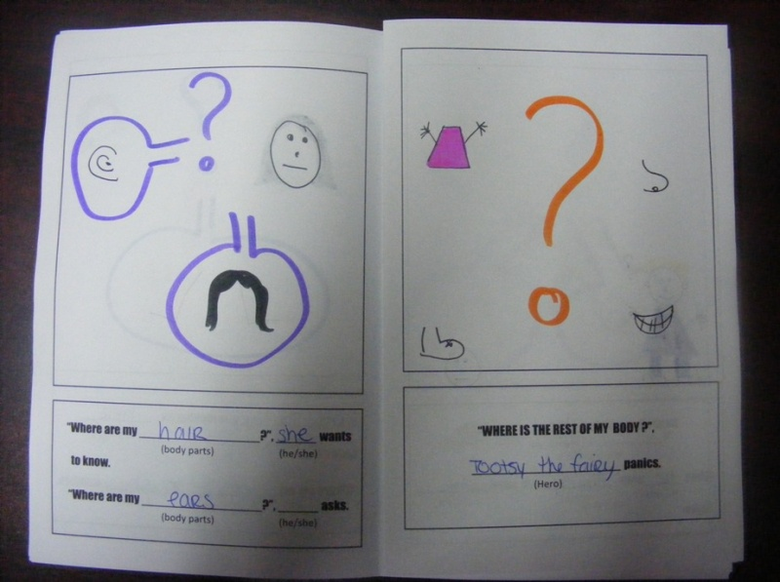

Appendix #8

Appendix #9