Week 1 - Around the world
Monday
9h00 | 7 min  7 min  7 min  10 min  7 min  20 min | - Play the good morning song  - Present the lyrics  - Say the switch rhyme  - Take the attendance  - Explain the ‘Kid of the Day’  - Write the date on the board  - Place the weather icon  - Show the map  - Ask the kids where they are from  - Give the kids a pin to place on the map  - Try to identify other countries  - Give a list of words for the week and explain the spelling bee.  - Talk about Africa and the language we speak there  - French, English, Arabic and other dialects  - Show animal flash cards  - Tell the giraffe story  - Play the 10 differences (need to be colored to have all the differences  - Take out colorings: African Animals
10h00 |  | - Take the snack
10h30 |  | - Go to the park
2h30 |  | - Take the snack
3h00 |  | - Review Animal flashcards  - Explain craft: Animal puppets

Good Morning song
Good morning, (Good morning)
How are you? (How are you?)
It’s so nice to have you here with me today
Good morning, (Good morning)
How are you? (Just fine!)
Howdee, how do you do, hello, good day!
Now that we’re together
Learning’s so much fun
The more of us the better
So come on everyone!
Good morning, (Good morning)
How are you? (Just fine!)
Howdee, how do you do, hello, good day!
Howdee, how do you do, hello, good day!
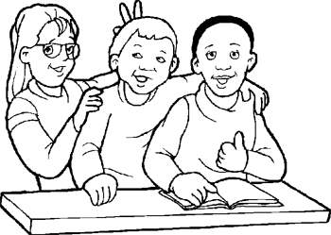

A new day is starting
Let’s use this time for learning
All the friends are here
So open wide your ears
French time is now finished
It’s time for fun in English!
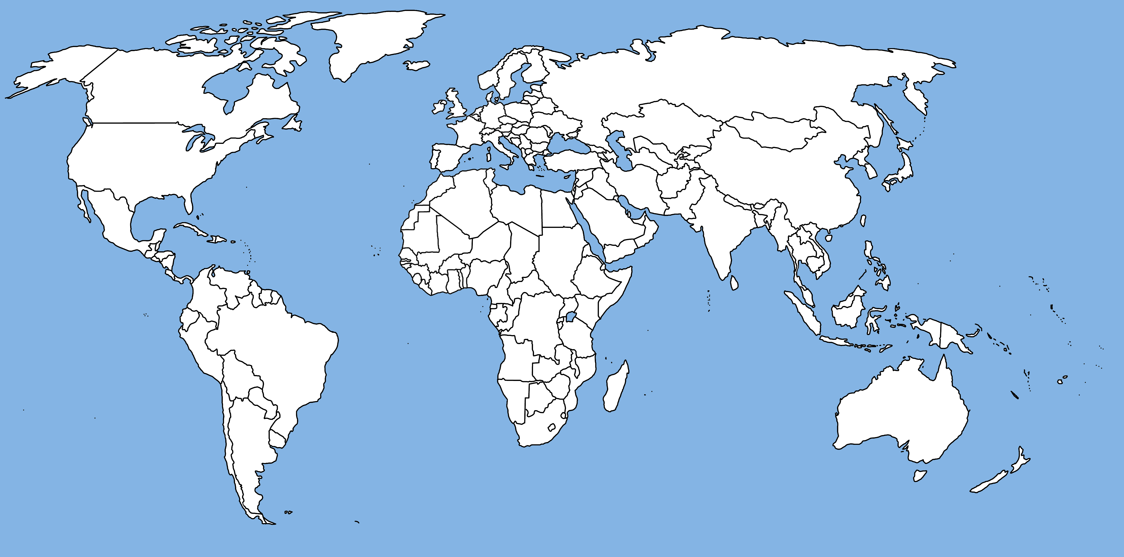

Theme: Around the world
Song Lyrics

Imagine (the Beatles)
Imagine there's no Heaven
It's easy if you try
No hell below us
Above us only sky
Imagine all the people
Living for today
Imagine there's no countries
It isn't hard to do
Nothing to kill or die for
And no religion too
Imagine all the people
Living life in peace
You may say that I'm a dreamer
But I'm not the only one
I hope someday you'll join us
And the world will be as one
Imagine no possessions
I wonder if you can
No need for greed or hunger
A brotherhood of man
Imagine all the people
Sharing all the world
You may say that I'm a dreamer
But I'm not the only one
I hope someday you'll join us
And the world will live as one

Waving Flag (K’naan)
When I get older, I will be stronger
They’ll call me freedom, just like a Waving Flag
(chorus) When I get older, I will be stronger
They’ll call me freedom, just like a Waving Flag
And then it goes back, and then it goes back
And then it goes back
Born to a throne, stronger than Rome
But Violent prone, poor people zone
But it’s my home, all I have known
Where I got grown, streets we would roam
But out of the darkness, I came the farthest
Among the hardest survival
Learn from these streets, it can be bleak
Except no defeat, surrender retreat

So we struggling, fighting to eat and
We wondering when we’ll be free
So we patiently wait, for that fateful day
It’s not far away, so for now we say

(chorus)

So many wars, settling scores
Bringing us promises, leaving us poor
I heard them say, love is the way
Love is the answer, that’s what they say,
But look how they treat us, make us believers
We fight their battles, then they deceive us
Try to control us, they couldn’t hold us
Cause we just move forward like Buffalo Soldiers
But we struggling, fighting to eat
And we wondering, when we’ll be free
So we patiently wait, for that faithful day
It’s not far away, but for now we say

(Chorus)X2

(Ohhhh Ohhhh Ohhhhh Ohhhh)
And everybody will be singing it
(Ohhhh Ohhhh Ohhhhh Ohhhh)
And you and I will be singing it
(Ohhhh Ohhhh Ohhhhh Ohhhh)
And we all will be singing it
(Ohhh Ohh Ohh Ohh)

(chorus)X3

Vocabulary
- animal - country - giraffe - monkey -flag
- buffalo - culture - hippopotamus - nationality
- cheetah - difference - language - ostrich
- continent - family - lion - tradition
- costume - friend - map - zebra

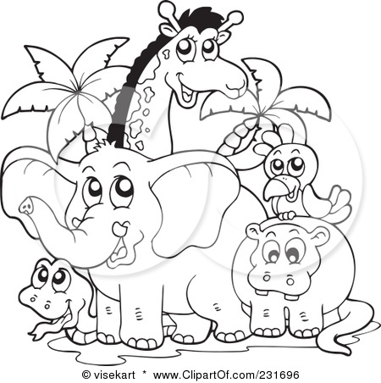
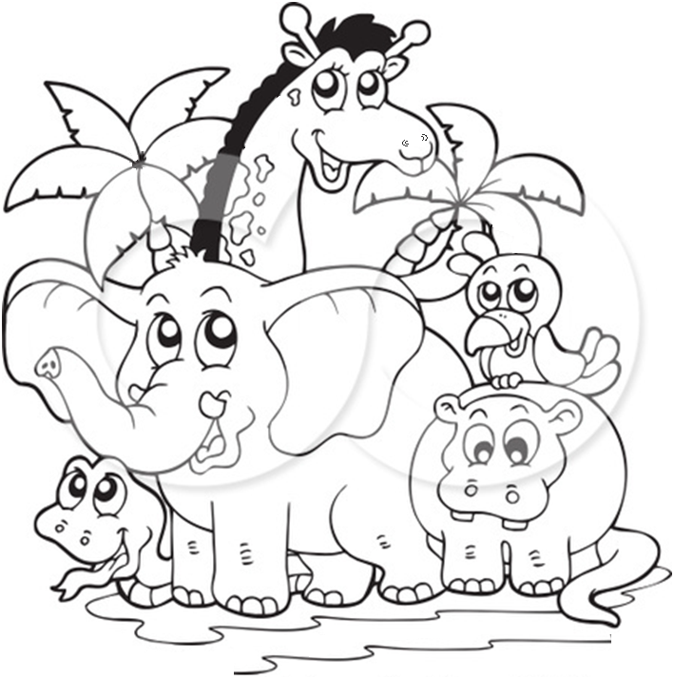

Week 1 - Around the world
Tuesday
9h00 | 5 min  5 min  5 min  10 min  10 min  10 min  10 min | - Play the good morning song  - Say the switch rhyme  - Take the attendance  - Indicate the ‘Kid of the Day’  - Write the date on the board  - Place the weather icon  - Review the word list  - Play match game  - Play the memory game  - Separate the game if too many kids  - Present the song of the day: Imagine  - Hand out lyrics + read  - Play the song  - Play a Day Camp game:
10h00 |  | - Take the snack
10h30 |  | - Go to the park
2h30 |  | - Take the snack
3h00 |  | - Explain the craft : Good Luck Hand  - Trace around your hand on a piece of construction paper or aluminum foil.  Cut the tracing out and glue it to a piece of construction paper. Decorate the hand with crayons, markers, glitter, glitter glue, glued on sequins, and/or bits of cut-up aluminum foil.  - Hand out the hidden word search  - Do a ‘ Look at the picture’

Week 1 - Around the world
Wednesday
9h00 | 5 min  5 min  5 min  5 min  5 min  20 min  15 min | - Play the good morning song  - Say the switch rhyme  - Take the attendance  - Indicate the ‘Kid of the Day’  - Write the date on the board  - Place the weather icon  - Review the word list  - Review song  - Tell a story: We’re different, We’re the same  - Review vocabulary of the face  - Draw a picture of your best friend  - Play a Day Camp game:
10h00 |  | - Take the snack
10h30 |  | - Go to the park
2h30 |  | - Take the snack
3h00 |  | - Explain craft: Japanese lantern

Week 1 - Around the world
Thursday
9h00 | 5 min  5 min  5 min  10 min  10 min  10 min  15 min | - Play the good morning song  - Say the switch rhyme  - Take the attendance  - Indicate the ‘Kid of the Day’  - Write the date on the board  - Place the weather icon  - Play memory game  - Play Monday Day camp game  - Present the song of the day: Waving Flag  - Hand out lyrics + read  - Play the song  - Flag quest
10h00 |  | - Take the snack
10h30 |  | - Go to the park
2h30 |  | - Take the snack
3h00 |  | - Explain craft: Build your own flag  - Book quiz

Week 1 - Around the world
Friday
9h00 | 5 min  5 min  5 min  20 min  10 min  15 min | - Play the good morning song  - Say the switch rhyme  - Take the attendance  - Indicate the ‘Kid of the Day’  - Write the date on the board  - Place the weather icon  - Fashion show:  - Describe your costume + present it to the other group  - Decode the message  - Spelling bee
10h00 |  | - Take the snack
10h30 |  | - Go to the park
2h30 |  | - Take the snack
3h00 |  | - Explain craft: Paper Plate Maracas

